Project Title:
An NLP-Based Prototype for Anomaly Detection in Cloud-Generated and Benchmark Cybersecurity Logs

Unit Code and Name:
COIT20265: Networks and Information Security Project

Assessment Title:
Assessment 4
Individual Reflection

Student Name:
Nafisa Sultana

Student ID:
12289859

Submitted to:
Unit Coordinator:
Biplob Roy

Mentor:
Ahmedi Azra

Due Date:
09/06/2026

1. Introduction
The capstone project focused on developing LogGuard AI, an NLP-based anomaly detection prototype for cloud cybersecurity logs. The objective was to design an intelligent system capable of collecting logs, detecting anomalous activities using artificial intelligence, generating automated alerts, and visualising security events through a cloud-based dashboard.
As a Software Engineer, I contributed to the implementation of the Random Forest model, revision of technical diagrams, documentation, model evaluation, and overall project integration. This project allowed me to apply concepts learned throughout my Master's degree in a practical cybersecurity application.

2. Understanding the Project Problem and Objectives
Modern organisations generate millions of system logs every day, making manual analysis inefficient and time-consuming. Traditional rule-based detection systems often fail to identify new or evolving cyber threats.
The primary objective of this project was to develop an intelligent anomaly detection prototype capable of analysing cybersecurity logs using Natural Language Processing and machine learning techniques while leveraging AWS cloud services for storage, monitoring, and alert generation.
Working on this project enhanced my understanding of intelligent cybersecurity monitoring systems and their practical application in cloud environments.

3. My Technical Contributions
Throughout the project, I contributed to several important technical tasks.
My responsibilities included:
- Implementing and refining the Random Forest anomaly detection model.
- Performing TF-IDF feature extraction and model evaluation.
- Comparing the performance of Random Forest, Isolation Forest, Bidirectional LSTM, and LogBERT.
- Revising the System Model, Detailed Dataflow Diagram, and Layered Network Architecture Diagram.
- Assisting in technical documentation and presentation preparation.
- Supporting dashboard refinement and integration activities.
Figure 1. Random Forest Implementation Results
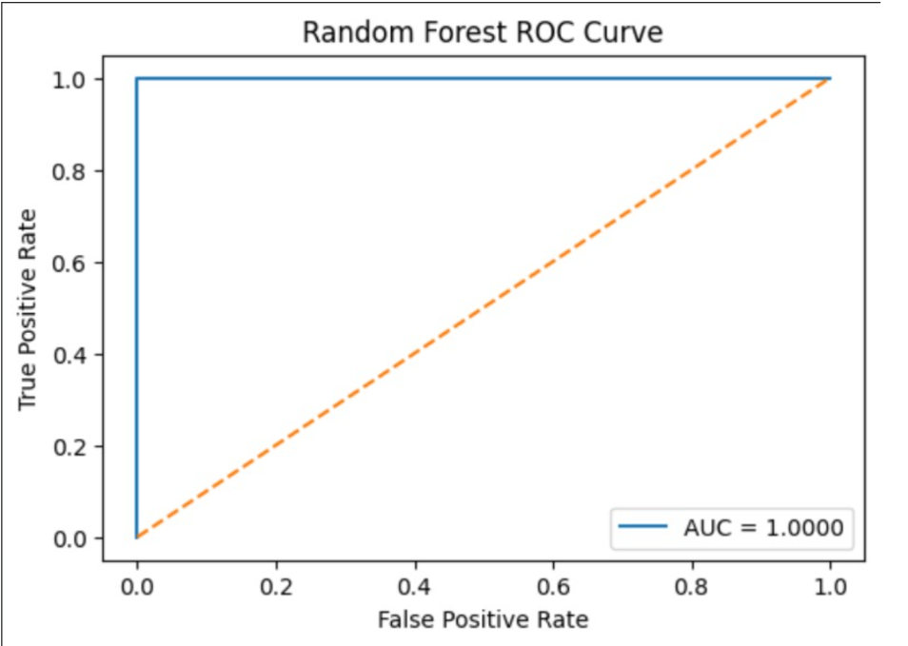
The Random Forest implementation allowed me to gain practical experience in feature engineering, model training, hyperparameter evaluation, and performance analysis using cybersecurity log data.

4. Knowledge and Skills Developed
This project significantly improved my technical knowledge across multiple domains.
I learned how transformer-based NLP models such as LogBERT differ from traditional machine learning approaches by learning contextual relationships within log sequences.
I also gained practical experience using AWS cloud technologies including Amazon EC2, CloudWatch, Lambda, API Gateway, SNS, and S3.
Implementing and analysing the Random Forest model strengthened my understanding of supervised machine learning, TF-IDF vectorisation, classification metrics, and cybersecurity data preprocessing.

Figure 2. Revised System Architecture
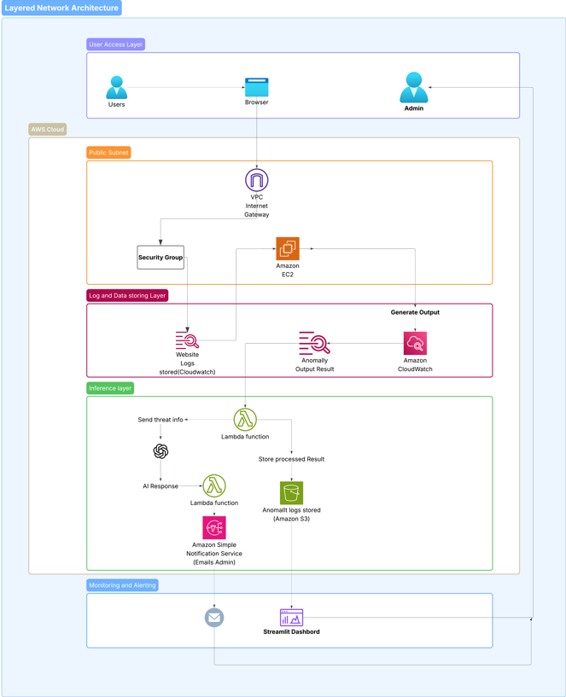
The architecture demonstrates the integration of cloud services, anomaly detection models, alerting mechanisms, and dashboard visualisation into a unified cybersecurity monitoring solution.

5. Challenges and Problem Solving
Several technical and organisational challenges were encountered during the project.
One major challenge involved integrating different technologies, including cloud services, machine learning models, dashboards, and data storage components.
Another challenge was understanding transformer-based models such as LogBERT, which required additional research into self-supervised learning techniques.
Mentor feedback also highlighted the importance of discussing model limitations, evaluation fairness, and technical trade-offs. Addressing these comments improved both the final report and my analytical thinking skills.

6. Teamwork and Professional Development
The project required continuous collaboration among team members.
Project activities were managed using Jira Kanban boards, while GitHub provided version control for collaborative development. Microsoft Teams and mentor meetings supported communication and project planning.
These experiences improved my teamwork, communication, and project management skills.
Figure 3. Jira Kanban Board
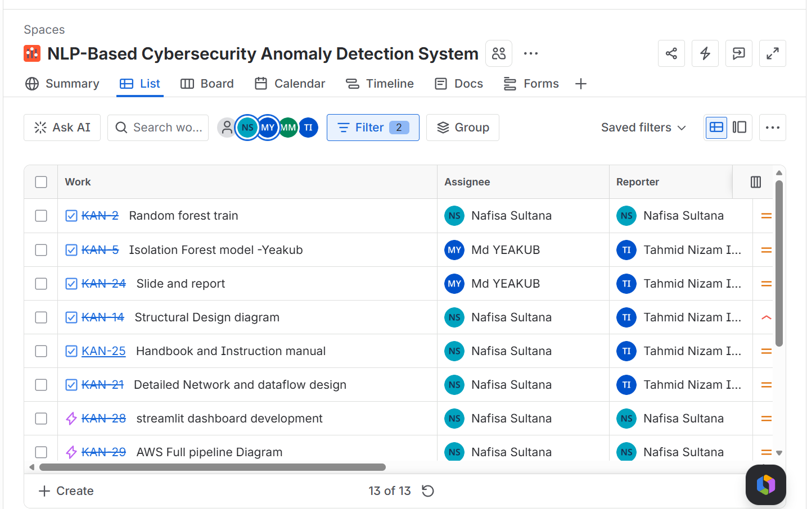The Jira board enabled effective task allocation, progress tracking, and milestone management throughout the project lifecycle.
Figure 4. GitHub Contribution History
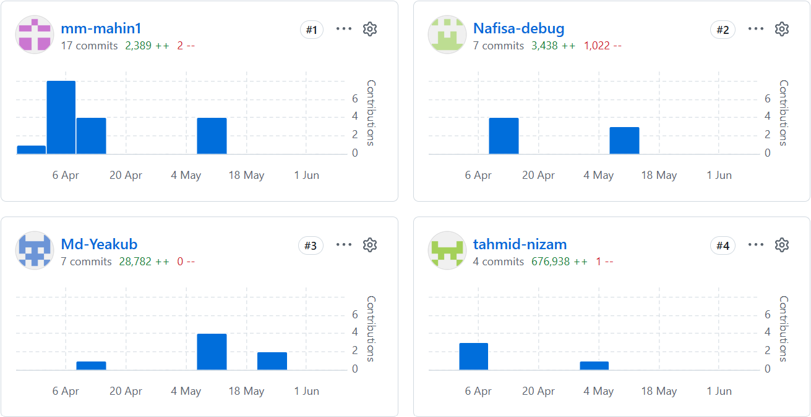GitHub facilitated collaborative software development and provided version control for code and documentation updates.
7. Professional Growth
This project strengthened my confidence in applying artificial intelligence to cybersecurity problems.
I improved my ability to analyse technical challenges, evaluate different machine learning models, prepare professional documentation, and communicate technical concepts effectively.
The experience reinforced my interest in pursuing a career in cybersecurity, cloud engineering, and AI-driven threat detection.
Figure 5. Streamlit Dashboard
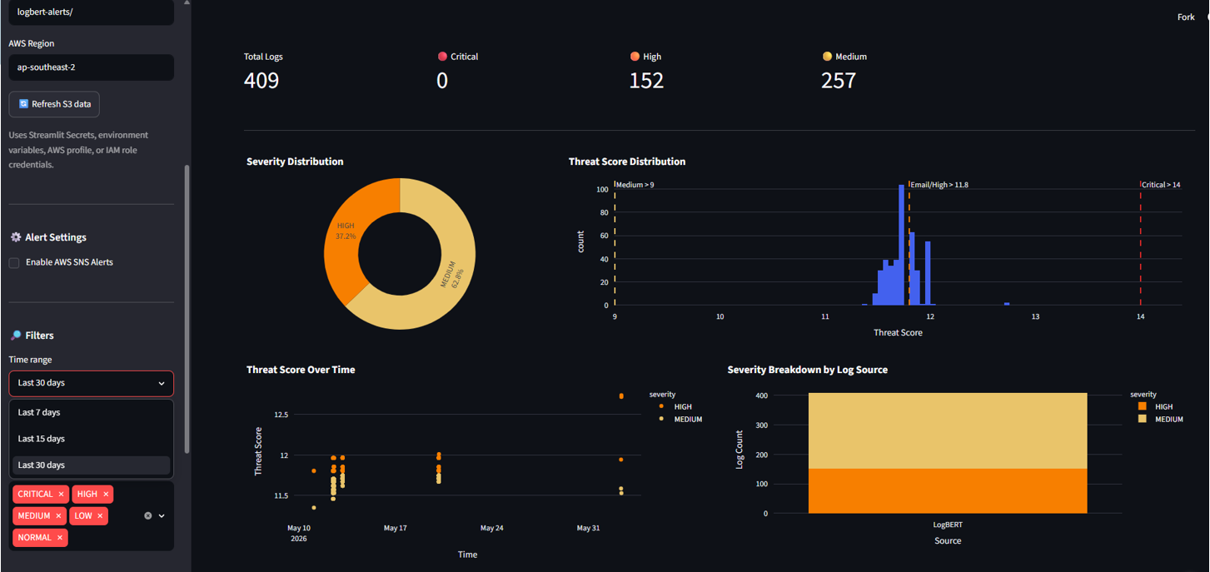

The dashboard demonstrates how anomaly detection results can be visualised to support real-time monitoring and decision-making by security analysts.

8. Reflection on Learning
Looking back on the project, I believe this has been one of the most valuable learning experiences during my Master's degree.
The project enabled me to combine theoretical concepts with practical implementation while working within a collaborative software engineering environment.
I learned that successful cybersecurity solutions require not only accurate machine learning models but also effective cloud integration, documentation, teamwork, and continuous improvement based on stakeholder feedback.

9. Future Improvements
Given additional time, I would implement complete CloudWatch-to-EC2 automation to achieve a fully integrated real-time anomaly detection pipeline.
I would also improve LogBERT evaluation using threshold-based classification metrics, reduce potential data leakage through independently labelled datasets, and integrate the NIST Cybersecurity Framework to provide more structured incident response recommendations.

10. Conclusion
Overall, this capstone project significantly enhanced my technical and professional capabilities.
My contributions to the Random Forest implementation, technical documentation, architecture revisions, and system evaluation provided valuable practical experience in cybersecurity and cloud computing.
The project strengthened my understanding of machine learning, Natural Language Processing, AWS cloud technologies, and collaborative software development while preparing me for future roles in cybersecurity and intelligent threat detection systems.

A3 Poster (Individual):

